WOODSIDE TRAIL GROUP HIKING PROGRAM
January thru May 2024

January 21, 2024

Woodside’s Hollow Creek Trail

When: Sunday January 21 at 10.00 am. Please note this is a Sunday hike.
Hike Leader: Jim Pierce email: jbpierce649@outllok.com phone 803-634-0513
Description: We have not hiked the Hollow Creek Trail in some time so let Jim show you what it is all about. This 5-mile trail is Woodside’s premiere hiking trail. Starting at Woodside’s trail parking area, we will join the loop after about 0.75 miles and then walk around the loop in an anticlockwise direction. After passing by several fairways of the Zoeller golf course we will walk through a forested area before coming to Anderson Pond dam where we will take a break and pick up any who want to do a shorter hike. From there we walk in a more remote area up the east side of Anderson Pond eventually crossing Hollow Creek and then back to our cars. The whole hike is 5 miles. If you wish to do a shorter hike [2.5 miles] meet the group at the dam at Anderson Pond Road at 10.45 am to complete the last part of the hike. We will bring you back to your cars after the hike. For planning purposes, If you intend to only do 2.5 miles, please notify the hike leader by Jan 18th.
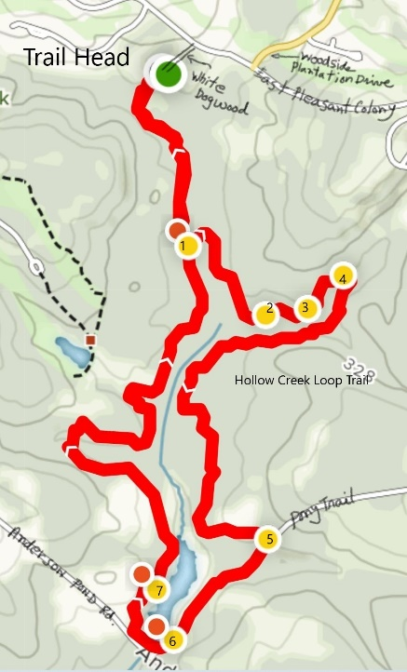
Meeting Place: At the Woodside Trail head parking area near the intersection of Woodside Plantation Drive and West Pleasant Colony Drive. Park in the parking area or along the maintenance road, if necessary. This starting point is within the gated community so if you need a pass to enter Woodside, please contact the hike leader. Those joining the hike at Anderson Pond dam will not need a pass since this parking area is outside the gated community.
Meeting time: Meet at 10 am
Distance: Entire trail – 5 miles. Anderson Pond dam to trail head parking area – 2.5 miles
Terrain: The first 2.5 miles of the hike is quite flat. The second 2.5 miles has some minor hills. This trail is usually dry.
Bring: Water. Good sneakers or hiking boots, snack. A walking stick might be useful.
-- Rain Cancels --
February 17, 2024
Congaree National Park
When: Saturday February 17, 2020. Start hike time at Congaree is 10:00am.
Hike Leader: Gerald McDonald, phone: 803-270-3310 or email: gerald21@me.com
Description: There are now 63 National Parks in the United States but there is only one National Park in South Carolina; Congaree National Park. It hosts an astonishing biodiversity and has the largest intact expanse of old growth bottomland hardwood forest remaining in the southeastern United States. You might not get the fanfare of Yellowstone's Old Faithful, Yosemite's Half Dome or the Grand Canyon, but with 25 champion trees the Congaree can boast having the largest tree species in the nation. No other area in North America has a larger concentration of champion trees.
The Hike: The park features more than 20 miles of hiking trails in the northwestern portion of the floodplain, the most popular being the 2.4-mile Boardwalk Loop, which is what we will hike. Raised nearly six feet above the forest floor, the elevated section of the walkway winds through a thicket of old-growth trees, ending at Weston Lake, once a channel of the Congaree River. The lower boardwalk takes visitors through a primeval bald cypress and water tupelo forest. Due to the Congaree River frequently flooding, certain areas of the park the route we plan to hike may have to change at the last minute. Sometimes the weather may be fine on the day of the hike at Congaree, but the trails might still be flooded due to rain from upstream. There is a beautiful 20-minute video on Congaree at the Visitor Center which we will look at. At the visitor center all hikers are encouraged to take a trail map copy.
Lunch: The Park has a covered area with tables which you could use for a nice picnic lunch. We will not be arranging lunch at a local restaurant. However, those who go might like the restaurant "California Dreaming" at 401 South Main St., Columbia. It is housed in the old Union Station also known as Atlantic Coast Line Railroad and Southern Railway Station. It was built in 1902, and is a brick and stone, eclectic Jacobethan Revival / Tudor Revival building. It features stepped gables and towering chimneys. It was designed by architect Frank Pierce Milburn for the Atlantic Coast Line Railroad and Southern Railway. It was added to the National Register of Historic Places in 1973. They take reservations.
Directions: Follow Interstate 20 East towards Columbia for 65 miles to Exit 64A. Merge onto Interstate 26 and follow for 8 miles to Exit 116, Interstate 77 North towards Charlotte (on the left). Follow Interstate 77 for 5 miles to Exit 5, Bluff Road. Exit 5 turn onto SC Hwy 48 East/Bluff Road. Drive approximately 8 miles and then take a slight right onto Old Bluff Road. Follow Old Bluff Road for 4.5 miles to the park entrance sign, which will be on the right. Proceed one mile to the Harry Hampton Visitor Center. Parking lots will be on the right. We estimate that it will take 1 hour and 27 minutes to drive to the park.
Those who want to carpool with others can park their car on the East Gate side of the Publix parking lot. You should plan to leave the Publix lot by 8:00am. There are restrooms available at the Congaree visitor center.
RAIN CANCELS

March 16, 2024

Langley Pond Loop
When: Saturday March 16th, 2023 meeting at 9.45 am for a 10.00 am start
Hike Leader: Laurie King-Pirchner, phone 585-261-3279, email laurie_kp@yahoo.com and Rita Hughson, phone 757-871-5126 email gdnldy@yahoo.com
Description: The Langley Pond Loop Trail is a 2.25-mile loop trail located near Warrenville, South Carolina that features some nice views of Langley Pond. It is rated as moderate. Dogs are also able to use this trail but must be kept on leash.
After we complete the loop we will walk down to the park area to see the upgrades/additions and inclusive playground that were part of the dam redevelopment project.
Meeting Place: We will meet at the trail head just off Langley Dam Road. Langley Dam Road intersects with Highway 1 near Langley Pond. There is a sign there pointing to Langley Pond. Coming from Aiken along Highway 1 that will be a left turn. A few feet down the road another road goes to your left and a sign points to the trail head parking.
Distance: 2.5 miles
Terrain: Rolling terrain, sandy trail, mostly through a forested area.
Bring: Good sneakers or hiking boots, walking stick, water, snack, and binoculars to observe birds in the marsh at the eastern end of the trail.

April 20, 2024

Lake Springs Loop Trail at Strom Thurmond Lake

WHEN: SATURDAY, April 20, 2024, 10am start
HIKE LEADER: Jim Parker (803) 443-5223 or parkerinaiken@atlanticbb.net
DESCRIPTION: A loop trail through wooded forest bordering J. Strom Thurmond Lake. Trail has several views of Lake Strom Thurmond. A short section of the loop is also a portion of the “Bartram National Recreation Trail”, a 27-mile-long trail starting just west of the Thurmond Dam. Consider arriving early and stopping to check out the Visitor Center at the east end of the dam for bathrooms, scenic views and interesting info about the dam, lake, etc.
MEETING PLACE: It is about an hour drive to the trail head. We suggest taking Furys Ferry Road east (aka highway 28) off River Watch Parkway in Augusta. On highway 28 after passing thru Clarks Hill, SC take a left onto highway 221. This road goes over Thurmond Dam. After the dam take the 3rd right turn onto Lake Springs Road to the trail head parking. Anyone wishing to carpool, meet at the parking area by Village Fitness (1st left after exiting the Village gate) at 8:30 am for an 8.45 am departure. This will allow 15 minutes for a bathroom break at the visitor center before leaving for the trailhead.
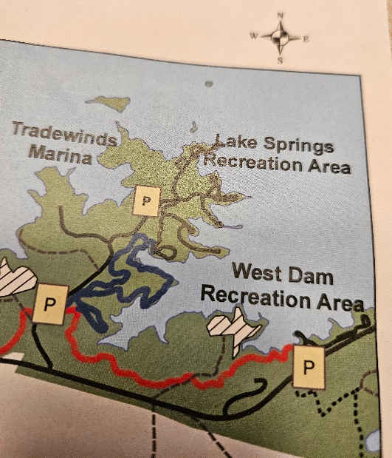

DISTANCE: About 3 miles
TERRAIN: Trail is a well-established mostly flat path with the usual occasional small hills and roots/rocks of forest hiking.
BRING: Suggestions would include drink, snacks, sneakers/hiking shoes and perhaps a walking stick.
AFTER WALK PICNIC: For anyone interested, there is a nice area just below Thurmond Dam with picnic tables and a scenic view of the mile long dam and the Savanah River. It is only about a 2- or 3-mile drive from the trail head. Wendy and I will be there and invite everyone to bring their picnic baskets, perhaps folding chairs, etc.
--RAIN CANCELS --

May 18, 2024

Flowers of Hitchcock Woods
When: Saturday May 18 at 9.00 am. Tentative schedule – depends on the flowers
Hike Leader: David Slaunwhite Email: dadonfoot@yahoo.com Phone: 858-926-8793
Description: One can stop and smell the roses and David did discover a Cherokee Rose in the Woods. Let us, instead, stop and smell the Kalmia. Join David on this 3-mile walk during which time he will acquaint you with the Kalmia and other wildflowers that grow in the Hitchcock Woods. We will enjoy the Kalmia trail as well as some other trails that are less traveled. There are no exams, but learning is encouraged.
The Kalmia are generally in bloom around Mother’s Day, so we have tentatively scheduled the walk for Saturday May 18, 2024. If the bloom varies, we will move the date and notify you in advance.
Meeting Place: South Boundary entrance to Hitchcock Woods
Meeting time: Meet at 8.45 am for a 9 am departure
Distance: About 3 miles
Terrain: Likely some hills and sand underfoot in some places.
Bring: Water, hiking boots or good sneakers. Camera and walking stick if desired.

-- Rain Cancels --

